July 13, 2023

Dear Sir/Madam:

For over 30 years, The Rotary Club of the Verde Valley has provided ongoing financial support for people and programs who need it most, including:

- College academic and vocational scholarships for local graduating high school students
- Local Interact Club at Mingus Union High School; Crutches 4 Africa delegate from Mingus HS
- Rotary Youth Leadership Awards (Leadership Camp for High School students)
- Verde Valley Imagination Library - providing 2,000 children with free books every month
- Habitat for Humanity’s Critical Home Repair program - helping seniors and Veterans
- Steps to Recovery Homes – providing safe, clean, and structured environments
- The Navajo Water Project – providing clean water to the Navajo Nation
- Ukrainian Relief Funds – supporting the Rotary Foundation, Global Relief Fund and KBC Ministries
- Project Prom Closet and Homecoming Closet – providing formal attire for local high school students
Our primary fundraising effort is the Duck Race held on Verde River Day. This event has raised more than $400,000 over the years to support many worthwhile programs. We know that you care about our community and with your continued support we can reach our 2023 goal of $35,000. Please consider sponsoring the 2023 Rotary Duck Race at whatever level you find comfortable. In addition to race tickets, you will be acknowledged in a newspaper ad and advertising at the event.
Sponsorship Levels:

$2,500 - Titanium level and 250 race tickets $1,000 - Platinum level and 100 race tickets
$ 500 - Gold level and 50 race tickets $ 350 - Silver level and 35 race tickets
$ 200 - Bronze level and 20 race tickets

When – September 30, 2023
Where – Dead Horse Ranch State Park – Verde River Day
1st Place -$1,000 2nd Place - $250 3rd Place - $100
To support this year’s Duck Race Fundraiser, please fill out and return the enclosed sponsorship form with your check. Alternatively, you can also donate online at www.rotarycluboftheverdevalley.org.
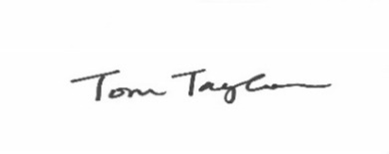
Thank you in advance for your support.
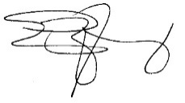
Eric Young Tom Taylor
Co-Chairperson Co-Chairperson

